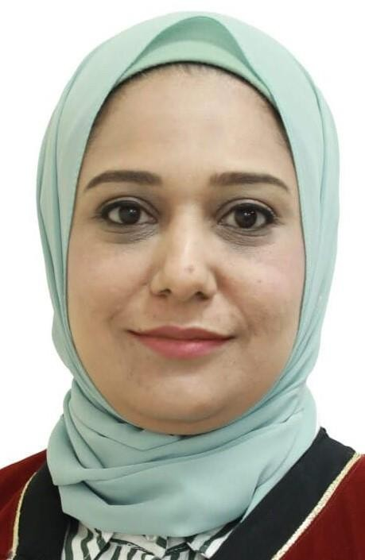

Dr. Rasha Attia
Assistant Professor at Physical Therapy Department, Faculty of Allied Medical Science, Philadelphia, Amman, Jordan
122K Pyramids Gardens, Giza, Egypt rattia@Philadelphia.edu.jo
Rashasamy660@gmail.com 0781367781-00201099945471

Education
- PhD in Physical Therapy - Basic Science Department- Faculty of Physical Therapy- Cairo University (2022).
- Master’s degree- Basic Science Department- Faculty of Physical Therapy-Cairo University (2013).
- Bachelor’s degree of Physical Therapy - Cairo University (2004) .

Experience
  - Assistant Professor at Physical Therapy Department, Faculty of Allied Medical Sciences, Middle East University, Jordan (2023-2024)
  - Vice President of Marsa Matrouh Pediatric Specialized Hospital, Egypt (2021 till May 2023).
  - Quality Team Leader and Coordinator at Marsa Matrouh Pediatric Specialized Hospital, Egypt (2020 till May 2023).
  - Head of Pediatric Unit in the National Institute of Neuromotor System, Egypt (2023)
  - Physical Therapist in the National Institute of Neuromotor System- General Organization for Teaching Hospitals and Institutes (2007 till 2014& from 2016 till 2019, and from 1st June-September 2023).
  - Owner and manager of Dr. Rasha Physical Therapy Center(2019 to May2023).
  - Head of Physical Therapy Department in Siwa General Hospital (2014-2016).
  - Physical Therapist in Hydrotherapy Department and Neurology Department in the National Institute of Neuromotor System (2006- August 2014).
  - Physical Therapist in El Galaa Specialized Hospital for Gynecology and Obstetrics (2007).
  - Physical Therapist in Dr. Emam El Negmy center for Physical Therapy (2004 to 2008).
  - Physical Therapist in Qobaa center for Physical Therapy (2006 to 2008).
  - Practitioner in Outpatient Clinic in Faculty of Physical Therapy and Kasr Elaini Hospital from (1/11/2004 to 31/10/2005).

Publication
- A Family History of Polyps in Patients with Colorectal Serrated Polyps Augments The Risk Of Colon Cancer In Jordan. Romanian journal for diabetes, nutrition and metabolic diseases, (2024).

- Effect of Siwa's sand bath versus sulphurous water bath on inflammatory biomarkers, pain, and physical function in patients with Rheumatoid arthritis. Fizjoterapia Polska, (2022).

Courses and Workshops
  - Application of National Safety Requirements NSR training Course (2022).
  - Crisis and disaster management course (2021).
  - Digital transformation course (Power point presentations, spread sheet, Operating system, Word processing, Fundamentals of database, Fundamentals of IT, Introduction to network) at FLDC, Cairo University (2021).
  - New Era in physiotherapy for sports injuries and EMG-Ministry of health and population (2017)
  - ACl injuries: Anatomical, Biomechanical and Neuromuscular consideration-NINMS (2016.)
  - Course and Workshop of (Principles of Taping) (2012).
  - The 12th annual Meeting of the General organization for Teaching Hospitals and Institutes (9-11 January 2008).
  - Physical therapy training course -Ministry of health and population (2007).
  - The Fifth scientific symposium: New Era in management of knee dysfunction -General physical therapy Syndicate, Egypt (2006).
  - Diagnostic Radiology Course (X-ray, C.T. and MRI), Kasr El Aini (2006).

Conferences Attended
    - The fifteenth international scientific conference of Faculty of Physical Therapy, Cairo University -Manual Therapy & technology in physical therapy (2014).
    - The fourth scientific conference of pediatric disorders and rehabilitation (NINMS,2014).
    - The Tenth international scientific conference Faculty of physical therapy, Cairo university -Physical therapy and Future challenges (2007).
      - The ninth international medical exhibition & conference-The 1st International conference of Orthosis and Prosthesis (2009).
    - The ninth international scientific conference -Physical Therapy is a safe Cure (2006).

